Renju lesson on January 31, 2002

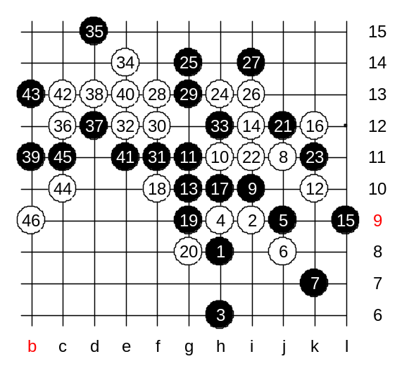
Hello everyone! Welcome to Online Renju Class. We continue with i10 today. Today we will continue checking the exciting variants of 5-j9. The lower 7th move is in our focus today as well. Move 8-j11 is familiar to us already. We know that after 9-g8 the outcome is about equal, right? We can check 9-i10 this time. This move, passive, therefore weak. White will play the most natural move. That is…? H11. I agree that black’s g11 is the strongest defense here. How to continue now? It is not easy to find good white move. Black will likely take the g10 point almost in any case. I feel white should develop towards right side space. That is the most promising plan. Ok, we try k10. Black will have to play g10 of course. Why? Because g20 is black’s only hope. Any other passive move would lead to white win pretty fast because of right side structure and space.
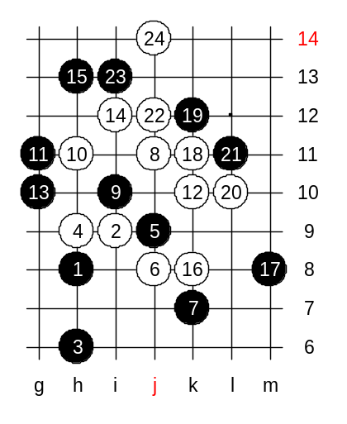
Let us try an active plan first – i12. Which block is necessary here? We can try both ends, ok? First lower. After strong k12 black is forced to defend with only moves. If white fails the attack then likely the k12 move should be changed to j12. Beautiful win though! Great!

Now we try the upper block, right? White wins fast here! In fact, it is straight VCT win. Show me the example ending here.

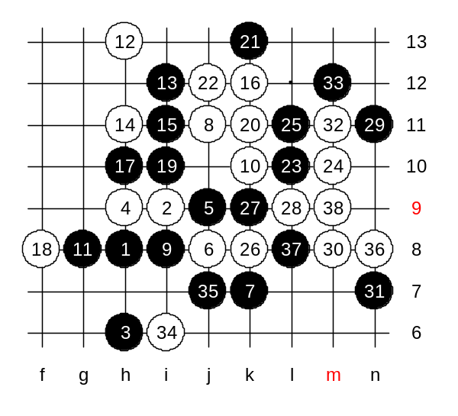
We just realized that passive 9th move did not bring any good for black. Therefore, another 9th move was popular 10 years ago. Yes, 9-i8, the mystery move of i10 opening. Ten years ago, the renju players were divided into two groups – ones who believe that white has sure win, and ones who thoguht that black is able to defend and win later instead. So, at that time, many people played this variant. I remember, in 1991, I was the fan of blacks and believed that black could defend. In my opinion at that time, white seemed to be very close to win, but something was disturbing every time though. The variant that you are about to see consists of forced moves for both sides. Any change from either side causes the win of the opponent. The truth about the variant? Well, nowadays I know 4 different white wins here. But if you do not know where the win is, you might not find even one. So, actually 9-i8 gives white sure win. Moves 12-h13 and 14-h11 prepare white’s attack.
There are 23 moves on board. All moves from 9 until 23 were forced.
I introduce one of the wins here. I tell about 24-m10 today. L11 is forced.
What if black goes 29th to upper side? Indeed, 4x4 comes soon.

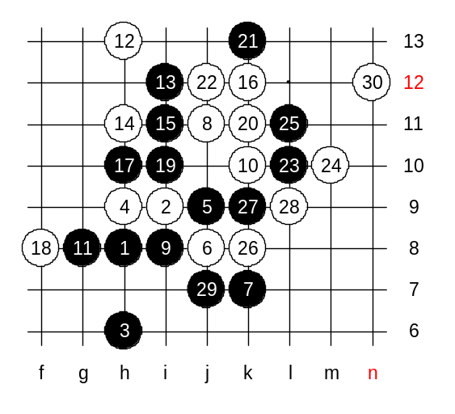
We change the 29th move now. How to win? Does anyone know? Yes yyfcsd, very good, he knows that only n12 wins here. No defense. Everybody can self find out why n12 wins. I remember Margus Tuvikene from Estonia found n12 move about 10 years ago. He was very young at that time. We learned that move from him.

